**Input and Output**

Based on the workflow and use case diagrams, the inputs of the system would be inventory descriptions and updates, parents and employees information, check in, check out and reservation time, and imported data. The outputs include asset availabilities, asset list, parents list, user list, customized inventory reports and exported the database as the system backup.

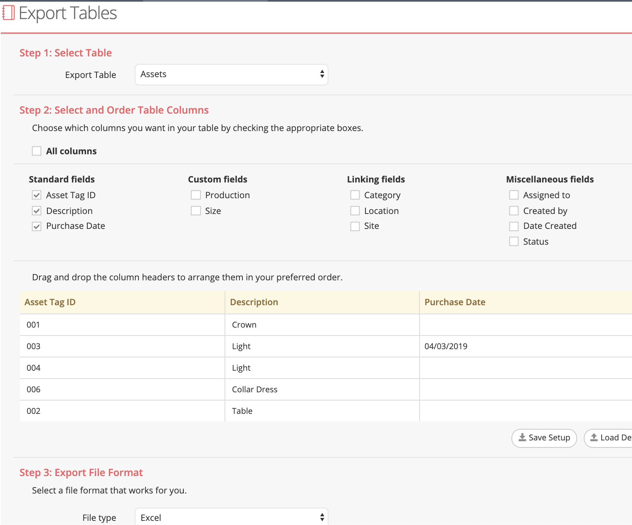

Asset Tiger Export Tables

**User Interface Design**

The User Interface was mostly carried out by AssetTiger, and we made customized changes sorting out the functions commonly used by the sponsor. The interface we spent more time on was the User Instruction, for which the sponsor specified her needs of having side views with instructions on the left side and screenshots on the right side.

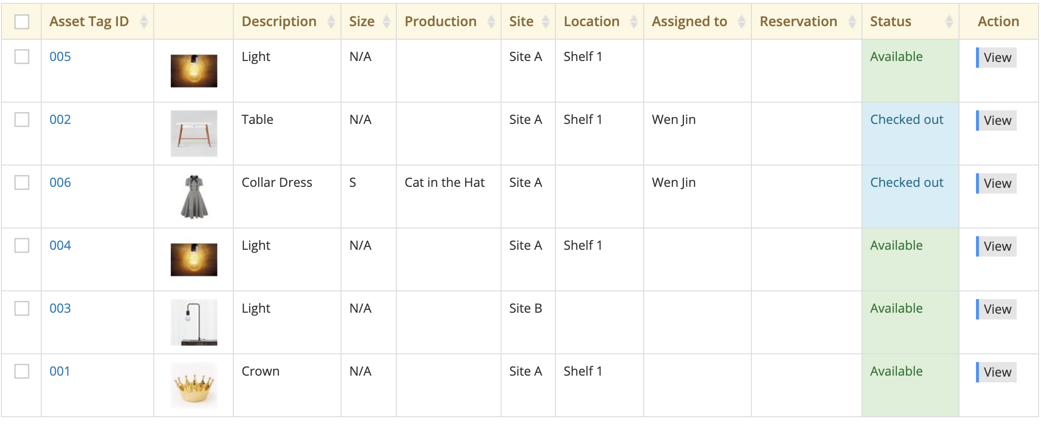

List Asset View

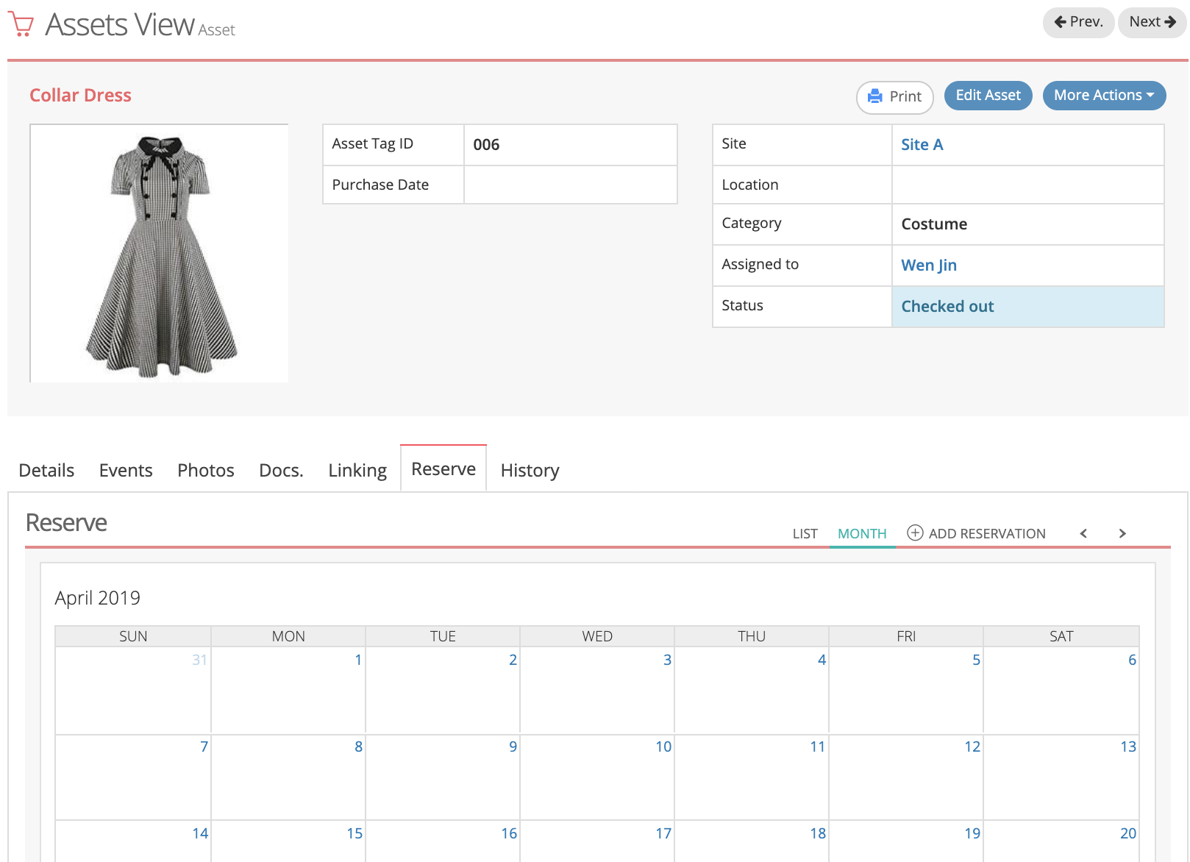

Detailed Asset View

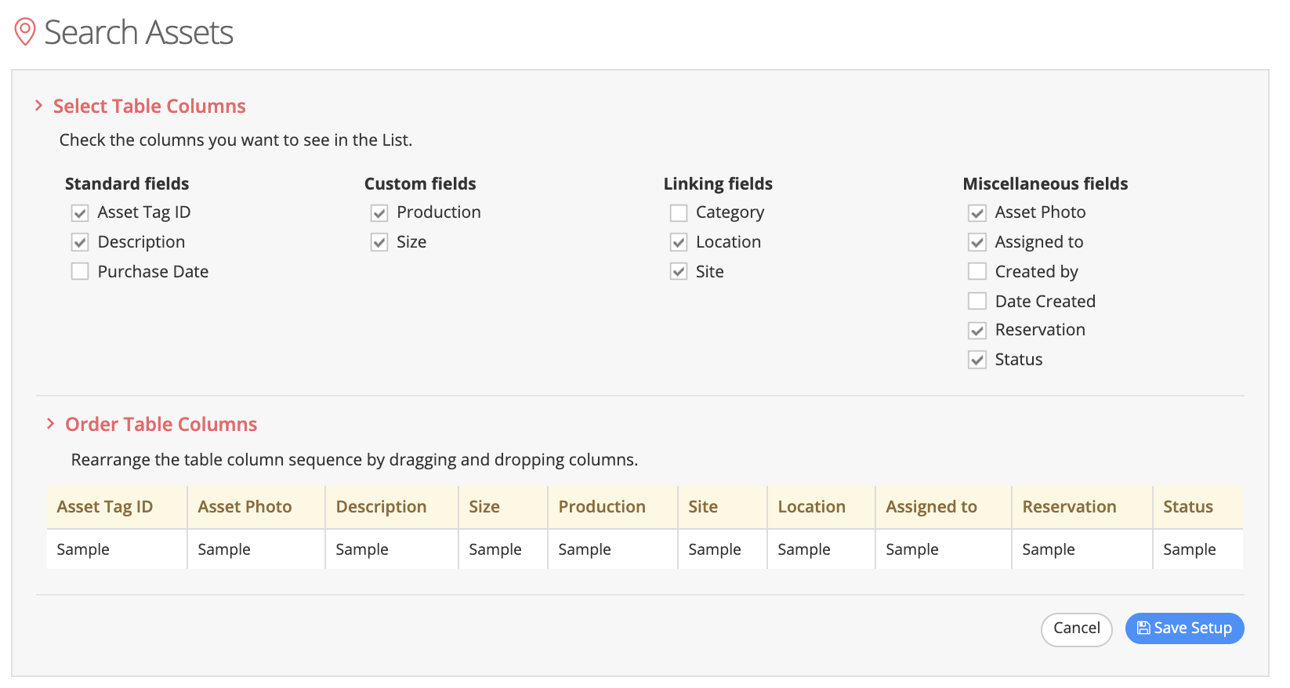

Asset Tiger Customizating Options

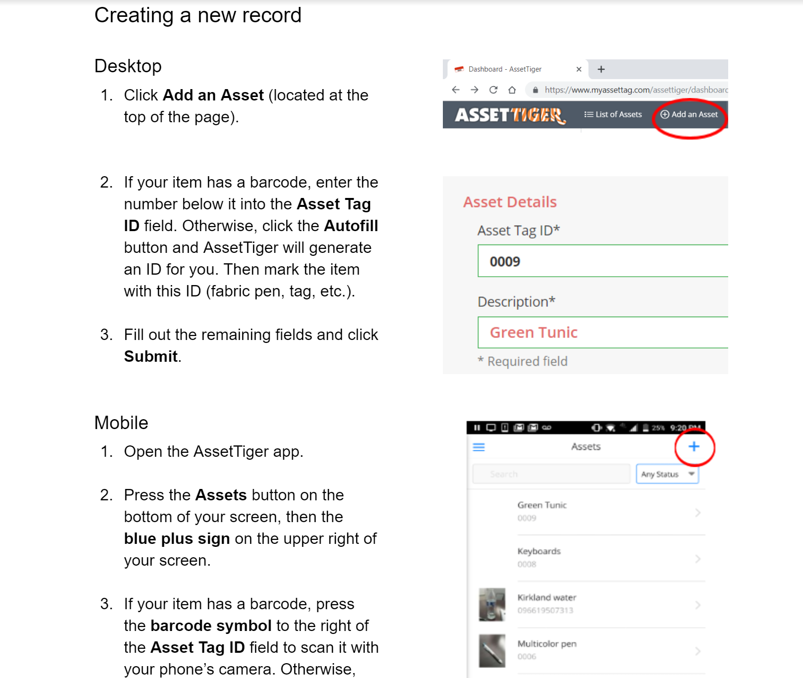

User Instructions Layout